KDU Assignment

1. Install any open-source Relational database like MySQL (or) Postgres
2. Create a database named “employee”

SQL Query: create databse employee



1. Create the following tables inside the “employee” database
   1. department (department_id, department_name)
      * department_id is the primary key

Ans. create table department(department_id int NOT NULL , department_name varchar(45) NOT NULL , primary key(department_id));  


* 1. employee (employee_id, employee_name, salary,department_id)
     + employee_id is the primary key
     + department_id is the foreign key that refers to department_id in the department table

Ans. create table employee(employee_id int PRIMARY KEY, employee_name varchar(45), salary int, department_id int, FOREIGN KEY(department_id) references department(department_id));  


1. Write Queries for the following
   1. Print employee_id, employee_name and department_name

Ans. select employee_id , employee_name , department_name

-> from employee , department

-> where employee.department_id = department.department_id;  
  
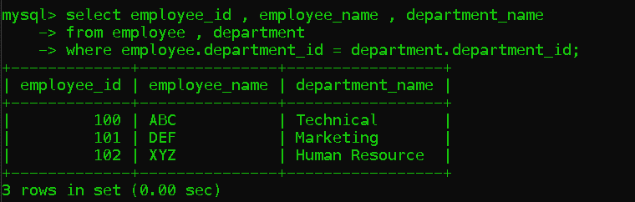

* 1. Write a Query that prints all the employees and their salaries in descending order of their salary

Ans. select * from employee

-> order by salary desc;  
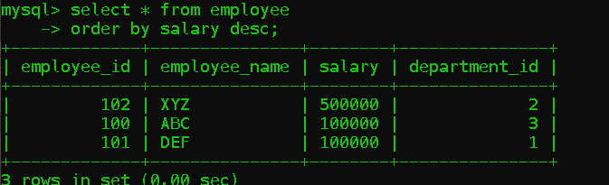

* 1. Write a Query that prints the average salary of employees in each department with the department name

Ans. select department_name , AVG(salary)

-> from department

-> JOIN employee using(department_id)

-> GROUP BY department_name;

